Neutral Diction

⚖️ What is Neutral Diction
# Source: AI Source: Provided by: [Data Path: Persons Table -> ID Column: 1, Name_En Column: Motasem Essam] -> From: [Chatgpt (GPT-4-turbo)] on [7/30/2025]
Neutral diction refers to language that is standard, clear, and objective, without being overly formal or informal. It avoids emotional, poetic, or slang expressions and focuses on clarity and straightforwardness.

✅ Key Features:
# Source: AI Source: Provided by: [Data Path: Persons Table -> ID Column: 1, Name_En Column: Motasem Essam] -> From: [Chatgpt (GPT-4-turbo)] on [7/30/2025]
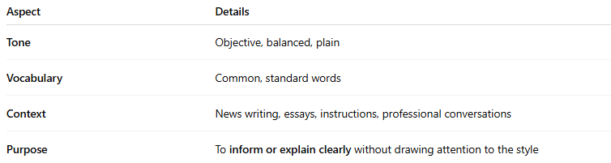
Aspect | Details
Tone | Objective, balanced, plain
Vocabulary | Common, standard words
Context | News writing, essays, instructions, professional conversations
Purpose | To inform or explain clearly without drawing attention to the style

🧠 Examples of Neutral Diction:
# Source: AI Source: Provided by: [Data Path: Persons Table -> ID Column: 1, Name_En Column: Motasem Essam] -> From: [Chatgpt (GPT-4-turbo)] on [7/30/2025]
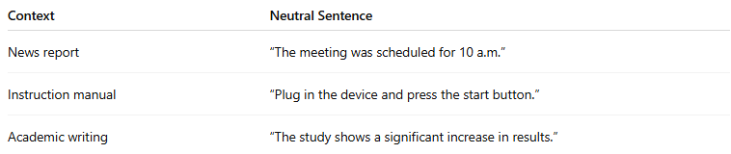
Context | Neutral Sentence
News report | “The meeting was scheduled for 10 a.m.”
Instruction manual | “Plug in the device and press the start button.”
Academic writing | “The study shows a significant increase in results.”

✍️ Example Sentences Using Neutral Diction:
# Source: AI Source: Provided by: [Data Path: Persons Table -> ID Column: 1, Name_En Column: Motasem Essam] -> From: [Chatgpt (GPT-4-turbo)] on [7/30/2025]
- “Please submit your assignment by Friday.”
- “The water began to boil after five minutes.”

🆚 Neutral Diction vs Other Types:
# Source: AI Source: Provided by: [Data Path: Persons Table -> ID Column: 1, Name_En Column: Motasem Essam] -> From: [Chatgpt (GPT-4-turbo)] on [7/30/2025]
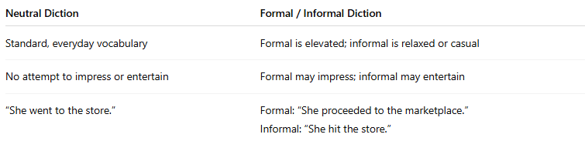
Neutral Diction | Formal / Informal Diction
Standard, everyday vocabulary | Formal is elevated; informal is relaxed or casual
No attempt to impress or entertain | Formal may impress; informal may entertain
“She went to the store.” | Formal: “She proceeded to the marketplace.”Informal: “She hit the store.”

🧭 Used In:
# Source: AI Source: Provided by: [Data Path: Persons Table -> ID Column: 1, Name_En Column: Motasem Essam] -> From: [Chatgpt (GPT-4-turbo)] on [7/30/2025]
- Essays and textbooks
- Technical instructions
- Professional communication
- Balanced journalism

